CATALOGUE

FOREWORD...............................................................................................1
SAFETY INSTRUCTIONS ..........................................................................2

CONTROL PART ........................................................................................5

IMPORTANT MARK .................................................................................10

PRE-OPERATION INSPECTION..............................................................17

SAFE DRIVING ........................................................................................21

RESERVOIR STORAGE...........................................................................23
MAINTENANCE AND INSPECTION........................................................25
COMMON FAULT TABLE ......................................................................40
TECHNICAL PARAMETERS ...................................................................44

FOREWORD
Thank you for choosing GREENMAN products. We attach great importance to your comfort and safety, so we strongly recommend that you read and follow the instructions and safety procedures in this manual. In order to avoid serious personal injury, you must follow this instruction. If you rent or lend to others, we suggest that you require the tenant to read this manual before operating the vehicle.
The manual is also applicable to the following models:

sales model | Name
L20 | golf car of 2 seats
GVG2 | Sightseeing car of 2 seats
GVG2+2 | sightseeing car of 4 seats
Take L20 as an example without special instructions.
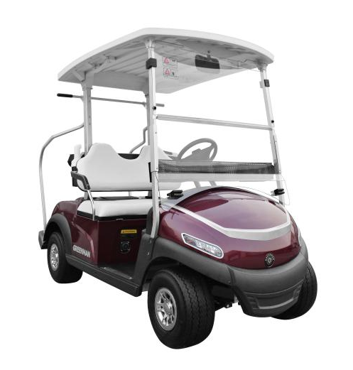
In operating the sightseeing car, please read and understand the contents of this manual.In view of we will continuously to a vehicle improvement, therefore, this manual content will not regularly updated and improved. If there are any changes to this manual, we will without prior notice, looking forward to understanding.If it appears that a service question is not answered in this manual, please contact with the retailer.

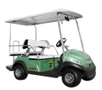

SAFETY INSTRUCTIONS

This manual introduces the characteristics of the electric vehicle in detail, and expounds the correct way to use electric vehicle, and points out the contents of daily maintenance. By carefully reading this manual, You will have a comprehensive understanding of the electric vehicles, and can better use and maintain your vehicle to avoid damage to your vehicle. Through correct maintenance, you can save a lot of money and avoid many accidents.
Please pay attention to the “DANGER”, “WARNING”, “CAUTION”statement and the warning sign posted on the vehicle when reading this manual,if not,you or vehicles may be harmed.If any operation or safety warning sign on the vehicle is damaged, it should be replaced immediately,to avoid property damage or personal injury.
Forbid any vehicle refit,especially for the electric control system, braking, steering system and other related security systems.Any refit without the producer allow may cause serious personal injury, and the manufacturer is not responsibility for any damage by vehicle refit.
This manual introduces the scope of allowing users to do it themselves.Please use the genuine parts supplied by GREENMAN.We shall not bear any liability for any direct or indirect damage caused by the use of non-genuine parts.

DRIVER QUALIFICATION
Only authorized people can drive this electric vehicle.We recommend that anyone with a valid license can drive this vehicle.Please attach the operating safety instructions and driving safety instructions recommended by the manufacturer to the car rental or parking places.We hope to attach relevant warnings in obvious places.

VEHICLE MAINTENANCE
- The vehicle and battery charger is repaired or maintained by professionally trained people.Even personnel who perform simple maintenance or repairs should have knowledge and experience in electrical and mechanical repairs.When servicing or replacing any parts, the corresponding operating instructions must be observed.
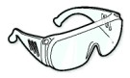
- Before disconnecting or connecting the battery,Place the FORWARD/REVERSE switch in the power off position(Median).Failure to follow this warning may result in battery explosion or serious personal injury.
- Wear safety glasses or approved eye protection when servicing vehicles or battery chargers.Wear full face masks and rubber gloves when working near batteries.
- When maintaining the vehicle or battery, it is forbidden to wear loose clothing or wear jewelry such as rings, watches and bracelets.
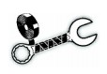
- Be sure to park the parking pedal in the locking position,and place the FORWARD/REVERSE switch in the power off position(Median) and Unplug the key before working under the car,to avoid damage caused by vehicle movement.
- Insulation tools should be used when working near a battery. Be very careful to avoid components or wires from shorting.
- Please record the date, person in charge and type of maintenance and check these records every once in a while.
- Please keep all signs, warnings and instructions provided by the manufacturer clean.

DANGER
Battery is explosive!NO SMOKING!Keep the vehicle and maintenance area away from sparks and flames.Keep ventilation when charging vehicles in closed areas.

Greenman do not provide lightning protection, flying objects or other storm related hazards protection.There is a storm when driving a vehicle,leave the vehicle and take shelter from the rain to a safe place.

WARNING
Regularly check the road on which the vehicle is driving

Be sure to make the vehicle safety through the following places:
- STEEP SLOPE:When a slope is found, limit the vehicle as much as possible to these places,and set some warnings,such as “Warning: the slope is too steep. Please make a detour”.
- SHARP TURN:Set up a warning to warn the driver to drive carefully.
- WETLAND:Wet grass can cause the vehicle to lose traction and affect stability, Surround the wetlands with ropes or chains and set warning.
- SOFT GROUND:Soft ground can cause the vehicle to lose traction and affect stability.Please repair the ground and set warning.
- THE ROAD OF MORE PEDESTRIAN:Please set up a warning sign to inform the driver to slow down.
- AIR CIRCULATION:Please keep the air flowing in the place where it is stored and maintained.It's very important because hydrogen is released when the battery is charged.

CONTROL PART
WARNING
If you rent or lend a vehicle, make sure that the driver is familiar with all controls and operating procedures before they can drive the vehicle.
When the vehicle starts, turn on the key switch, place the forward/reverse switch in the “forward” position, step on the accelerator pedal, and the vehicle moves forward; place the forward/reverse switch in the “back” position, step on the accelerator pedal, and the vehicle will retreat.
Do not change the forward/backward switch and close the key switch while the vehicle is moving. To avoid injury to the passengers or damage to the vehicle, be sure to stop the vehicle before changing the "Forward/Reverse" switch.
When it is necessary to stop the vehicle, first release the accelerator pedal, and then firmly press the brake pedal until the vehicle stops. To avoid inadvertently starting the vehicle, when leaving the vehicle, be sure to set the "Forward/Backward" switch to the Neutral position, turn the key switch to the "Close" position and remove the key .

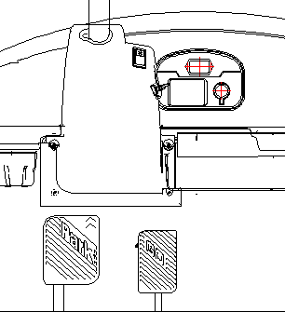
Driving Light Switch
Forward and Backward Switch
Key Switch
Electricity Meter
Compass
Brake Pedal
Acceleration Pedal

Figure 1 Control panel

Acceleration Pedal
Parking Brake Pedal
Brake Pedal

Figure 2 This mechanism for mechanical parking vehicles

Key Switch
The key switch is located on the column shroud at the bottom right of the steering wheel, as shown in Figure 1. The switch has two gear positions. "OFF" and "ON" are clearly marked. When the vehicle starts, the key switch is set to "ON".
Note: The key can only be removed when the key switch is in the "OFF" position.
Forward and Backward Switch
The forward and backward switch is located below the steering wheel, as shown in Figure 1. When the vehicle is moving forward, set the forward/backward switch to the "forward" position. When the vehicle is reversing, the forward/reverse switch is set to the “back” position, and the reversing buzzer will generate a reversing alarm. After the vehicle stops, set the forward/reverse switch to the neutral position (balance on both sides). At this time, the vehicle will not run even if the accelerator pedal is depressed.
Acceleration Pedal
The accelerator pedal is located on the right and there is a “GO” on the pedal, as shown in Figure 2. The accelerator pedal of this vehicle is different from the accelerator pedal of the car. When the key switch is in the "ON" position and the "forward/reverse" switch is not in neutral, the vehicle can move forward or backward. As the accelerator pedal is gradually depressed, the speed will gradually increase until full speed. When the accelerator pedal is released, the power will be cut off and the motor will stop working.
Brake Pedal
The brake pedal is a large pedal on the left, with the word "STOP" printed on it, as shown in Figure 2. To decelerate or stop, press the pedal with your foot.
CAUTION
When driving downhill or at high speed , use the brake pedal appropriately to control the speed.
When parking the vehicle, please avoid parking on the slope. If you can not avoid it, you must make sure that the vehicle is parked securely, and the driver can leave the vehicle .
Parking Pedal (For Mechanically Parked Vehicles)
The parking pedal is a panel in the upper left corner of the brake pedal. The word "PARK" is engraved on it, as shown in Figure 2. This pedal is used when the driver wants to leave the car. Depress this pedal into the locking position to prevent the vehicle from moving.

WARNING
The parking pedal in the locked position can be released regardless of whether the accelerator or brake pedal is depressed. (This applies to mechanical parking vehicles)
Electricity Meter
The function of this instrument is mainly to display the remaining power of the battery. (If there is no special requirement, the vehicle is equipped with a simple electricity meter)
Compass
When the vehicle is driving, indicate the driving direction for the driver

Trailer Switch
The switch is located under the seat, lifts the movable seat (on the rear cover) and can be seen on the seat bracket trailer switch.
To drive the vehicle, the trailer switch must be placed in the "forward↑" position. When the toggle switch is in the "back↓" position, the vehicle is in the trailer. When the trailer switch is in neutral, the vehicle is in a power-off state and cannot be driven.
In addition to the trailer, any other operation does not require the trailer switch to be placed in the "back" position.
If the trailer switch can not be placed on the trailer even if it is placed in the“back”position, the motor brake can be unlocked manually (As shown in Figure 3): Open the motor maintenance port, install the release lever on the motor brake, and firmly move the release lever in the direction of the right main beam to separate the brake from the motor rotor and hold this state to release the brake.
Brake Release Lever
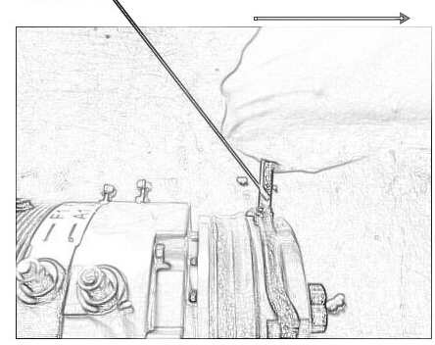
Figure 3 Manual release of the electronic parking
Driving Light Switch
The headlight switch is located on the left side of the column shroud (as shown in Figure 1). When the headlight switch is set to the O position, the headlight is turned off; when the headlight switch is set to the I position, the headlight is on.

IMPORTANT MARK
The Serial Number of the Vehicle
The frame number of the vehicle is on the rear cross member of the chassis. As shown in Figure 4
Explanation:
Please keep a record for ordering parts with your dealer.

The serial number of the vehicle
Figure 4 Frame

Windshield Warning
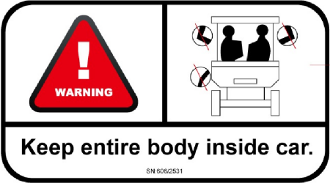
Never drive any part of the body out of the vehicle while driving, and be sure to sit firmly.
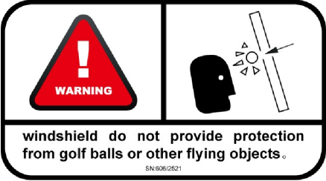

The windshield cannot provide blow protection from golf balls or other flying objects.

Charging Warning
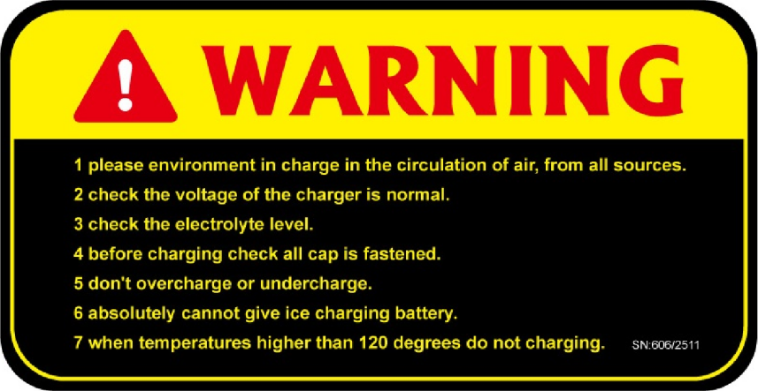
The contents of the charge warning label are matters needing attention when the vehicle is charged, and the label is located above the charging stand.
- Please charge in an air circulation environment, away from all fire sources.
- Check if the charger's voltage is normal.
- Check the electrolyte level.
- Before charging check all caps are fastened .
- Do not overcharge or undercharge.
- Never charge a frozen battery.
- Do not charge when the temperature is higher than 120 degrees.
Battery Warning
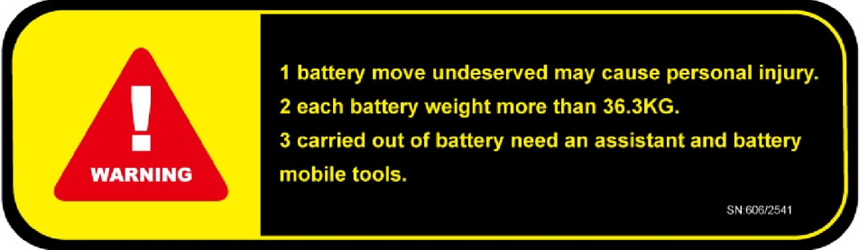
The content of the battery warning label is a precaution when the battery needs to be moved. The label is located on the seat cover (Open the seat to see).
1. Improper movement of the battery may cause personal injury.
2. The weight of each battery exceeds 36.3KG.
3. Take out the battery requires an assistant and use the battery to move the tool.
Motor Cover Warning
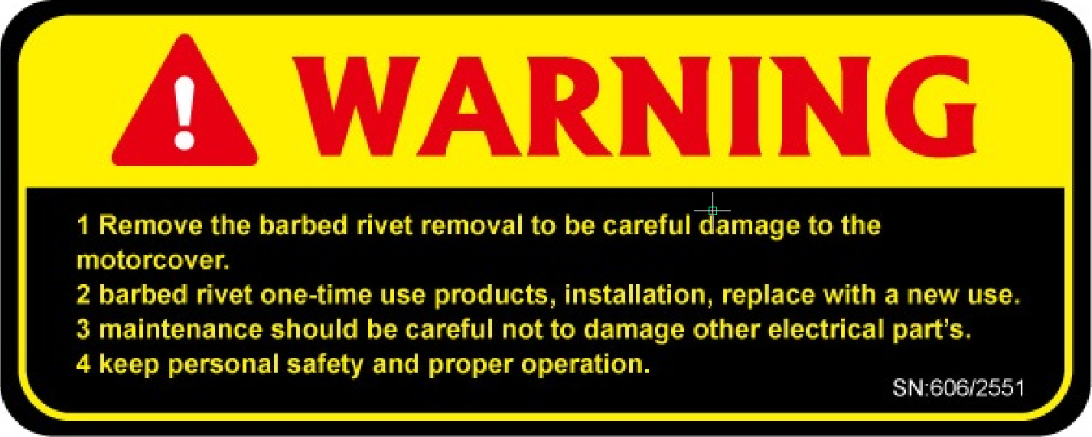
The contents of the motor cover warning label are the matters needing attention when servicing the motor. The label is located on the motor cover.
- Remove carefully detached barbs fixation nail to prevent damage to the motor cover.
- Barb fixing nails are disposable items. Please replace them with new ones during installation.
3. Be careful not to damage other electrical parts when servicing.
4. Pay attention to personal safety, correct operation.

Cup Holder Warning
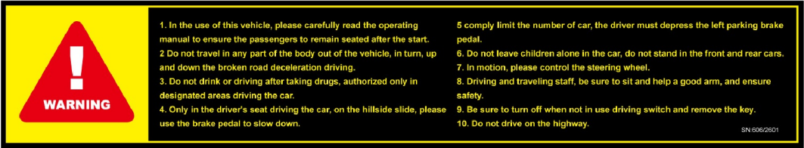
The content of the cup holder warning label is a matter to be noted when the vehicle is driving, and the label is located under the dashboard.
1. Before using this vehicle, please read the operation manual carefully to ensure that the passengers start up after sitting.
2. Do not extend any part of the body out of the vehicle during driving. Decelerate driving when turning or descending a slope.
3. Please do not drive after drinking or taking medicines. Authorized persons can only drive the vehicle in designated areas.
4. Only drive the vehicle in the driver's position. When coasting on a hillside, use the brake pedal to slow down.
5. Obey the limit of the number of passengers, and be sure to depress the parking brake pedal when the driver leaves.
6. Do not leave children alone in the car, do not stand in front of and behind the car.
7. Please control the steering wheel while driving.
8. The driver and passenger must sit well and grasp the handrails to ensure safety.
9. Be sure to turn off the travel switch and remove the key when not in use.
10. Do not drive on the highway.

Steering Wheel Warning
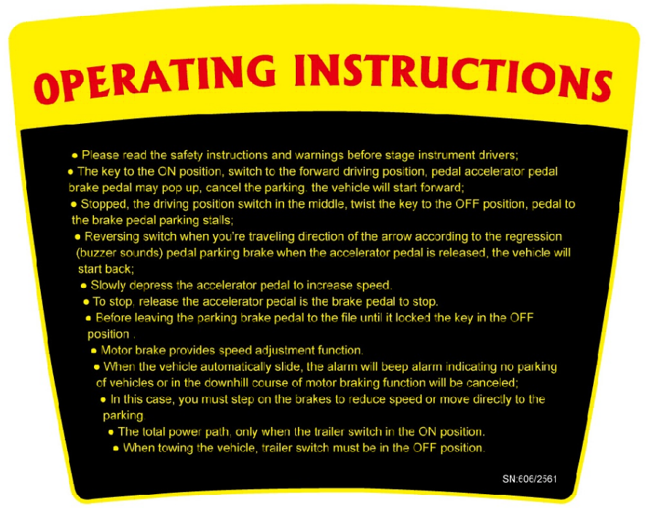
The content of the steering wheel warning label is the method of vehicle operation. The label is located on the steering wheel.
- Please read the instructions and the safety warning in front of the dashboard before driving the vehicle.
2. Place the key in the ON position, and set the travel switch to the forward position. If you step on the accelerator pedal, the brake pedal will automatically pop up. The parking will be cancelled and the vehicle will start to move forward.
3. When stopping, place the travel switch in the middle position, twist the key to the OFF position, and apply the brake pedal to the parking position.
4. When reversing, press the drive switch in the direction of the reversing arrow (the buzzer will sound). When you step on the accelerator pedal, the parking brake will be released and the vehicle will start to reverse.
5. Slowly press the accelerator pedal to increase speed.
6. When parking is required, release the accelerator pedal and press the brake pedal.
7. Before leaving the vehicle, step on the brake pedal until it locks, and place the key in the OFF position.
8. Motor brake provides speed adjustment function.
9. When the vehicle is automatically taxiing, the alarm will beep to warn that the vehicle is not parked or the motor's braking function is about to be cancelled during the downhill.
10. In this case, you must first step on the brakes to lower the speed or park directly.
11. The total power path, only when the trailer switch in the ON position.
12. When towing the vehicle, trailer switch must be in the OFF position.

Controller Warning
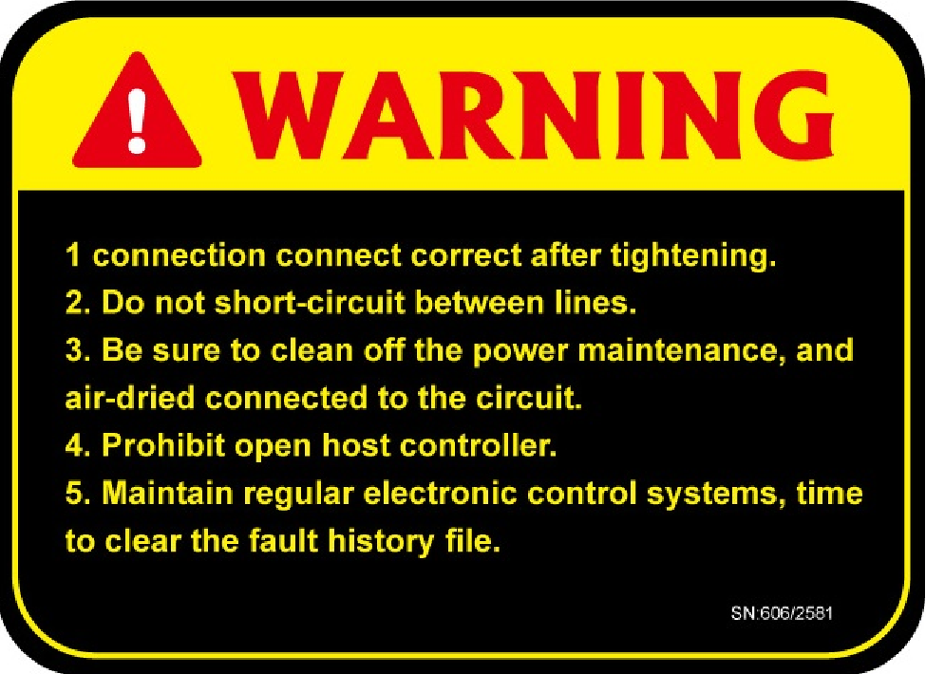
The contents of the controller warning label are matters needing attention when the controller is maintained. The label is located on the controller cover.
1. Tighten after the wiring is correct.
2. Do not short circuit between lines.
3. Be sure to turn off the power before cleaning and maintenance.
4. It is forbidden to open the main controller.
5 electronic control system timing maintenance, regularly clear the fault history file.

Tire Warning
The content of the tire warning label is the air pressure when the tire is inflated, and the label is located above the tire.

Vehicle nameplate
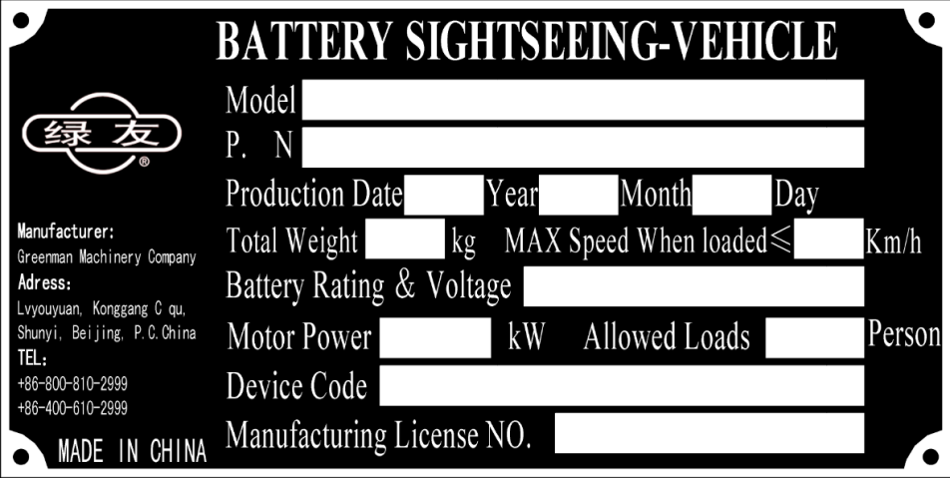
The contents on the vehicle nameplate are the basic parameters of the vehicle and company contact information. If the customer has a problem with the vehicle, you can contact the company through the contact information on the nameplate. The nameplate is located on the seat bracket mounting plate.

PRE-OPERATION INSPECTION
Each vehicles is thoroughly inspected and adjusted at the factory. However, when you receive a new car, familiarize yourself with the controls, indicators, and operations of the vehicle, and check each car to ensure that it is in good working condition.
Please use the following checklist as guidance when checking the vehicle. Please check daily according to the checklist whether the vehicle works well and implement a regular maintenance plan.

WARNING
Before performing an operation check, make sure that the vehicles key has been removed to avoid accidents, make sure the parking brake pedal is stepped into the lock position to prevent the vehicle from moving.
Checklist before operation
Please check the following items before each use:
- Battery
1. Ensure that the battery is firmly installed. In the process of exercising an electric vehicle, it is inevitable that there will be bumps, and a battery with a firm installation will not cause the circuit connection of the battery to fall off due to vibration and thus cause power interruption.
2. Please check that there is no missing battery cover to prevent the acid liquid from flowing out of the battery.
3. Keep the surface of the battery clean so that the vent hole on the fill hole cover or screw plug is not blocked, and check whether the pole is eroded.
4. Plug in the key and start the vehicles.Check whether the electricity meter shows sufficient power, please determine the distance of the trip according to the electric quantity, and charge it in time.Please remove the key and proceed with the following inspection.
2. The tyre situation
1. Check whether the tires are normal, the air pressure is too high or too low will affect the performance of the tire or vehicle,Tire pressure of 20 psi (137 kpa, 1.4 KGF/c ㎡).
2. Before each use, check the vehicle tire usage, if badly worn or damaged, cracks, and sharp objects to Pierce the tyre, if you have any of the above, it is prohibited to use, please adjust or replace a new tire, otherwise it will damage the vehicles or the life of a tyre explosion, it will cause safety accident;When the tire pattern is worn down to less than 0.04 inches (1mm), please replace the tire immediately.
3. Check whether the wheel nut is loose or missing, and tighten or supplement when necessary.
3. Body and chassis
1. Before each use of the vehicle, inspect the vehicle body for damage or loss of certain components, determine whether these damages or loss of certain components affect the running of the vehicle. Check whether the bolts of the connection components are loose and fall off. Important parts: front windshield fixing bolts, electric vehicles top fixing bolts, rear backrest fixing bolts, etc. If loose or falling off, please use the vehicle after fastening, and contact the after-sales staff if any bolts are missing.
2. Check whether the windshield is clean, whether it is cracked or damaged. If it is not clean, clean the windshield in time to prevent the dirt from obstructing the driving vision. If there is any crack or damage, please contact the after-sales personnel to replace it.
3. Check whether the wiring harness and tubing at the chassis are detached, and if it falls off, it should be fixed back in time.
4. Check whether the chassis and body are hooked up to foreign objects, whether there is any foreign matter on the top of the vehicle or may affect driving; if any, remove these foreign objects in time to avoid affecting safe driving.
4. performance checking
After you are familiar with the vehicle controls and reading driving instructions, you can conduct a test drive. Please test drive on the wide road.
Daily checklist
Please use the checklist below as a guide for checking the vehicle and daily inspection.
- Forward/backward switch
After inserting the key to start the vehicle, push the forward/reverse switch to the forward gear, depress the accelerator pedal, and the vehicle moves forward, then the vehicle is no problem. Turn the forward/reverse switch to the reverse gear, step on the accelerator pedal, and the vehicle moves backwards, no problem.
- accelerator pedal
Check the accelerator pedal to ensure that it can work flexibly. If it is stuck or not returned, please adjust and repair the fault promptly,if you continue to use it, there are potential safety hazards that may cause serious safety accidents and personal injuries.
- braking system
Check the brake pedal. When the brake pedal is pressed, it feels powerful, when it is released, it can return to its original position. Check if the brake function is normal, if there is a brake failure, use of the vehicle is prohibited. Please have professional maintenance personnel perform the adjustment and maintenance to avoid a safety accident. When applying the appropriate pressure to depress the brake pedal, the stroke of the brake pedal should not reach the floor rubber, and the vehicle should stop smoothly within 4.3 meters (14 feet). If the pedal stroke hits the floor or fails to stop within 4.3 meters (14 feet), check the brake system and make the necessary adjustments.
- parking brake
When the parking brake pedal is pressed into the lock position, the vehicle remains stationary (in the 20% incline and within).When the accelerator pedal or brake pedal is pressed, the pedals are automatically flipped open.

- Back-up buzzer
When the current forward/reverse switch is in the “ (backward) “switch, the Back-up buzzer will sound a warning tone, which can effectively alert the surrounding personnel.
- steering system
Move the steering wheel up and down and back and forth to make sure that the steering wheel is fastened. Turn the steering wheel to check if the steering system has overmuch idle, If you find that there is has overmuch idle, or you hear a loud noise, then there are parts that need to be replaced or adjusted, please repair or maintenance immediately.
- Inspection of lamp and electrical components
Plug in the key and start the vehicles.Open and close the headlight switch check headlight to work properly, open and close a turn signal switch to check if a turn signal to work properly, hit the brakes to check whether the brake lights to work properly, press the horn to check the horn is working correctly.
- general inspection
When driving normally, pay attention to the abnormal voice, such as short roll or quack, and check the performance of the vehicle.

SAFE DRIVING
WARNING
Reiterate: Greenman Electric Vehicle is only suitable for people with special equipment operating permits! If you are operating an electric vehicles for the first time, please operate it under the supervision of trained technicians to avoid accidents!
- operating steps
- Insert the key and twist the key to the "ON" position;
- Switch the forward/reverse switch, select the direction of travel, and determine that there is no obstacle in the direction of travel;
- When the accelerator pedal is slowly depressed, the parking pedal in the locked position will automatically release and the vehicle will begin to move. As the accelerator pedal is gradually depressed, the speed will gradually increase until it reaches full speed;
- When parking, release the accelerator pedal and press the brake pedal. Mechanical parking model: After parking, the parking brake pedal should be firmly pressed until it locks, This is to prevent the vehicle from sliding. E-parking models: Automatically locked after parking for 3 seconds. The electric vehicle slowly stops, and after the vehicle stops, the forward/reverse switch is placed in the median position.
Note: If the forward/reverse switch is switched to the median position (balanced on both sides), the power will be switched off and the vehicle will stop operating.
- Driving considerations
- Only those who have studied and trained are allowed to drive the vehicle;
- Before driving, ensure that the passengers are firmly seated and grasp the handrails. The passengers must not lean out of the vehicle while the vehicle is in motion;
- In a slippery, crowded or complex road section, slow down and drive carefully;
- When driving on turning sections and downhill sections, attention should be paid to deceleration or braking. Drive carefully to avoid accidents;
- WARNING
Because the vehicle is not designed for driving on the highway, it is not allowed to drive on the highway, otherwise the consequences are serious;
- WARNING
Because the vehicle is manufactured strictly in accordance with the vehicle design standards, the vehicle must not be converted without permission after shipment. Otherwise, the consequences are serious;
- WARNING
It is forbidden to go overboard, and it is easy to damage electronic components;
- WARNING
It is forbidden to drive the vehicle after drinking or taking stimulant drugs;
- This vehicles is suitable for closed places with good roads such as golf course, community, and scenic spots. The center of gravity of the vehicle and the clearance from the ground are relatively small. Therefore, the vehicle is not suitable for driving on roads with serious unevenness so as to prevent obstacles from damaging the vehicle chassis;
- After the electric vehicle is used, it should be parked indoors because if it is left outdoors for a long time, rain (in the case of rain) will penetrate into the interior of the electric vehicle, causing damage to electrical components and rusting of mechanical parts, reducing the service life of the electric vehicle.

RESERVOIR STORAGE
WARNING
1. Place the FORWARD/REVERSE switch in the power off position(Median) to prevent the vehicle from accidentally starting or the fire hazard to facilitate the mobile vehicle.
2. Only professional technical personnel can carry out a series of services such as maintenance and maintenance of the vehicle.
3. Please do not charge the frozen battery to prevent explosion hazard.

CAUTION
1. Low-power batteries will freeze at low temperatures.
2. Avoid exposing electrical components to damp environment.
3. Do not use any type of pressure cleaning equipment to clean the vehicle.

Storage preparation
- Check the battery level (including winter) for at least the first two weeks before storage to ensure proper mixing of water and electrolytes.
- Unload the vehicle so that the tire only supports the weight of the vehicle.
- Turn the key switch to OFF position, remove the key, and keep the forward/backward switch in neutral position.
- If the vehicle is installed with other accessory parts, please close all accessories, including GPS devices, fans, etc.
- Place the trailer switch in the trailer position.
Note: all functions, such as instrumentation and information, are disabled when the
FORWARD/REVERSE switch is placed in the power off position.
- The surface of the battery shall be clean and the pole shall not corrode.
- Store the vehicle in a cool and dry place and reduce the self-discharge of the battery.
- check the tire pressure up to 20 psi (137 kpa, 1.4 KGF/c ㎡).
- Make regular lubrication every six months.
- Thoroughly clean the front body, rear quarters, seat, battery compartment and the underside of the vehicle.
- Do not use the parking brake and plug the wheels with a wedge to prevent rolling.
- Keep the battery charged during storage, and charge the battery at least once a month（see battery maintenance for details）.

We are not responsible for the failure of the user to maintain the battery due to the proper operation of the vehicle.

MAINTENANCE AND INSPECTION

The friction surface of the moving parts will wear out after a long drive. the working state of the system and components will be changed in order to guarantee the vehicle use with good condition and safe operation, must be conducted in accordance with the provisions, regular inspection and maintenance.

CAUTION
Please make sure to turn off the key switch before maintenance.
When replacing parts in vehicle maintenance work, we must change the parts of our original equipment, and we can't change the model and specification.

Maintenance table维 护 表
 | Note | Before operating | A month  20circle  20hours  100miles  160km | Half a year  125circle  125hours  600miles  1000km | Every  Year  250hours  1200miles  2000km | Two years  500circle  500hours  2500miles  4000km | Four years  1000  circle  1000  hours  5000  miles  8000km
Before operating | Charging | S | S | S | S | S | S
 | Clean the battery and check whether the battery nut is loose. | S | S | S | S | S | S
 | Check the brake | C | CA | CA | CA | CA | CA
 | Check steering system | C | C | C | C | C | C
 | Check tire pressure and surface damage | C | CA | CA | CA | CA | CA
 | Check the body and chassis | C | C | C | C | C | C
 | Check whether the nut is loose | C | C | C | C | C | C
 | Check reversing alarm | C | C | C | C | C | C
A month | Check the liquid level of the electrolyte |  | C | C | C | C | C
 | Check contact points for damage |  | C | C | C | C | C
 | Clean and lubricate the pedal control position |  | CL
Every six months | Check the insulation have cracks and damage |  |  | C | C | C | C
 | Check the shock absorber for leakage and spring damage |  |  | C | C | C | C
 | Check whether the harness is loose or worn |  |  | CS | CS | CS | CR
Every year | Discharge test |  |  |  | S | S | S
 | Add electrode protectant |  |  |  | S | S | S
 | Check brake pad thickness and rear axle |  | C | C | C | C | C
 | Check the direction clearance and adjust the wheels |  |  | CA | CA | CA | CA
 | Check the wheel screws and the front wheel bearings |  |  |  | C | C | C
 | Check the rear axle gear oil and leakage |  |  |  | C | C | C
 | Check and adjust brake |  |  |  | CA | CA | CA
Every four years | Replace the rear axle gear oil |  |  |  | R | R | R
 | Check whether the lubricant has been leaking out and if there is any need to adjust the rear axle |  |  |  |  |  | CA

Periodic inspection定 期 检 查
- General accident prevention measures
Each mechanical device should be handled carefully during maintenance to prevent accidental injury.
The following points should be noted:
- Because the accumulator produces flammable gas, do not smoke in the vicinity or make spark, open fire.
- If the vehicle is only supported by a jack, please do not enter the bottom of the vehicle to ensure safety.
- Do not connect the battery's positive and negative electrode (tighten the battery wrench), or there will be a short circuit, spark, or even a battery explosion.
- Steering system
Check lube oil when steering system is not sensitive or abnormal.
- Meter check
Turn the key switch to "ON" position, check the power indicator light and the electric meter enters the normal working state.
- Check the headlights, horns, and turn signals
Switch on each switch to check whether the headlights are working properly.
Step on the brake pedal to check whether the brake lights work properly.
Turn on the switch to check whether the horn and steering lamp are working properly.
- The braking system
Brake
Check whether the tyre is worn out, whether the brake drum is hot, check whether the brake is normal, check whether the brake line has corrosion wear.
Parking brake
Parking brake is a method of electronic braking. stop the vehicle, turn off the key switch, push the vehicle, check if the vehicle is moving. If the mechanical parking is used, check whether the ratchet of the ratchet is badly worn,whether the parking is normal.

- The steering wheel

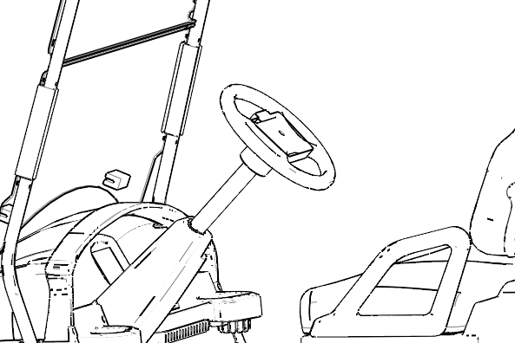

Turn the steering wheel from left to right to check if there is a lag. Slow down and check if the steering wheel is smooth and noiseless. If there is any abnormality, it should be checked and adjusted immediately.
- Brake and accelerator pedal

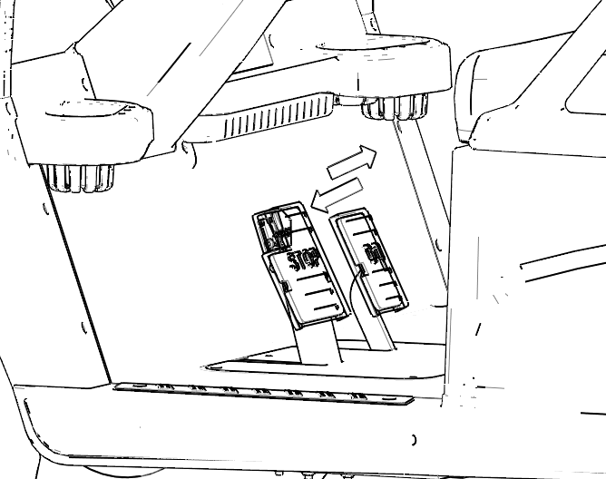

Check the brake and accelerator pedal stroke smoothly, without delay, release the pedal to have the rebound force.
- Tire
Check the tyre pressure for the specified pressure. Check the tire crown wear condition.
- Wiring harness
The wiring harness is installed at the main girder at the bottom of the vehicle to check whether the wiring harness at the bottom and back of the car is loose or worn. If there is any looseness or wear, please handle and repair it in time, so as to avoid short circuit (short circuit may cause fire).
- Insurance
The insurance of electrical components is located in the controller assembly and DC converter. When replacing insurance, open the controller cover, remove the insurance, and choose the same insurance when replacing.
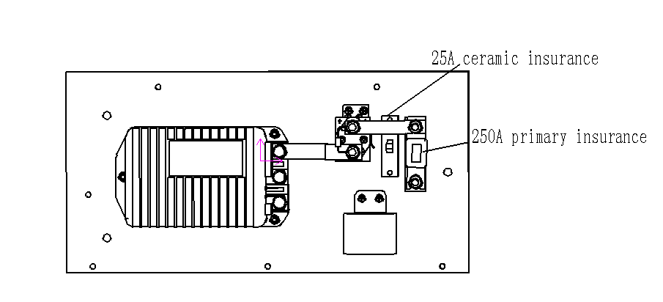

WARNING
The main fuse is blown out and should be checked the vehicle route. When replacing fuse,must conform to specified specification,can not use metallic conduit to make temporary substitution, otherwise easy to produce excessive current, cause important electric element to burn even fire.

- Battery
Check for loose connection of battery wire, check the battery liquid surface. Due to high temperature in summer, the battery liquid evaporates quickly and needs to be checked every week to replenish the distilled water in time.
If the vehicle has been stopped for a long time, it should be charged every other month.

Battery for use and protection电 池 使 用 及 保 养
The battery provides the power for the vehicle, the perfect maintenance and charging can make the vehicle battery achieve the best effect and extend the life.

CAUTION
SAFELY RULES
- Wear goggles, mask and gloves in accordance with safety standards.
- The battery should be away from spark, open-flame, and no smoking.
- Never open the lid which is not allowed to open on the battery.
- Tighten the vent and keep its level when deal with the electrolyte.
- Ensure the working area is well ventilated.
- When booster, charging and test the battery, prohibit tilt the battery. Never let the battery in the angle where electrolyte could outflow.
- When using metal tools or conductor, please be more careful, in case of a short circuit and sparks.
- To prevent short circuit, please don`t put anything on the battery.
- As the electrolyte is a mixture of water and acid solution, please avoid skin contact.
- If skin or eyes contact with the acid, please rinse immediately with plenty of water.
- Don’t add water into the normal battery.

Battery cleaning
The surface of the battery should be kept clean and should not be dusty. If the battery pole is corroded, wash the white powder with ammonia or baking soda first, polish it with sandpaper and clean it with clean water, then apply grease or vaseline. Be careful not to let the detergent enter the battery.

Battery charging
The prerequisites for charging a vehicle are as follows:
- Please read the manual provided by the charger before charging. Please charge the battery according to the instruction manual of the charger.
- When the battery is charged, it releases hydrogen. It needs to be charged in a ventilated environment.
- It is forbidden to smoke near the battery when charging.
- It can only be charged by the charging machine designated or provided by the manufacturer.
The following points should be noted when charging:
- The customer should accurately grasp the charging time according to the actual situation in the process of use, refer to the frequency of vehicle use and mileage, and grasp the charge frequency. If the meter indicates that the red light is on, it should be charged. If the red light is flashing, it should stop running and charge as soon as possible, otherwise the over-discharge of the battery will seriously shorten the life.
- when the running time is short, the charging time should not be too long, otherwise the battery will be overcharged and the battery will be heated.
- The average charging time of the battery is about 10 hours, ensuring that the battery is charged to 100% every time.
- When charging if the battery temperature over 65 ℃, should immediately stop charging.
- When charging, pay attention to the cable of the charging seat can't be released, so as to avoid heating when charging, or even burn the charging base.
- The battery can not have the oxidation or the pole loose contact, avoid the battery heating when recharging.
- when the charger is charging for the battery, please do not remove the ac plug directly. If you need to interrupt the charging, pull out the charging gun first, then disconnect the 220V alternating current.

Replace the battery
When there is a problem with the battery pack, the customer can not change the battery privately, so the customer needs to contact the maintenance personnel of the original factory. When the battery replacement is required, only the same batteries as the original specifications can be replaced, and the specifications of the battery can not be replaced.
The following points should be noted when assembling the battery:
- The tool should not be placed on the battery to avoid short circuit and accident.
- To disarm the negative terminal of the controller (-) to be removed and to be insulated and installed at the end of the installation.
- Do not lock the battery pressure plate too tightly, so as not to damage the battery shell.
- When replacing the new battery, it also needs to replace the battery line in time to avoid the corrosion of the battery line.
- When replacing the battery line, choose the line length and the same size as the original.
- When tightening the battery nut, use a torque wrench or a general manual wrench, and no pneumatic or electric wrench is allowed.

WARNING
Binding post can’t twist too tight otherwise it will lead to terminal melt fracture or fire.

Battery watering
Add water frequency depends on the battery usage and working temperature. Please check the battery every few weeks to determine the frequency. Usually the longer the battery is, the more frequent to add water.
Full charge before adding water. If the plate naked, please only add water to discharge or part of a rechargeable battery to draw the plate, then for a full charge, and continue to add water as below step.
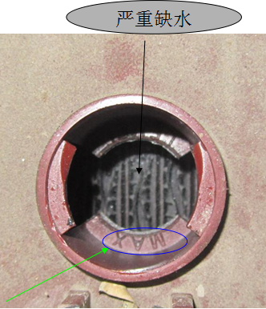
Open the vent cap, don't let the dust into the battery, and check the electrolyte level.
Liquid level is too low
If the electrolyte level is much higher than plate, it needn’t add water.
Add water until the electrolyte level is 1/8 below the bottom of the fill well. A piece of rubber can be used safely as a dipstick to help determine this level.
After adding water, please fix vent cap on the battery.

Detection
Eyeballing and clean: Test battery whether the cable is loose, terminal is corrosion, battery box body and the case cover is blowout or leakage. If can't repair, please change the battery. If the battery terminal is corrosion, bracket or fixed rust, or the battery is dirty, please take the time to clean up, cable brush can be used to clean up dust, corrosion and rust. Wipe the top of the battery with water and soda dust, and then use wet cloth to wipe, rust on the parts after cleaning, rinse off with clear water, dry and paint.
Measure the proportion and open circuit voltage: The charge level of batteries can be learned by measuring the specific gravity and open circuit voltage.
Mauritius are listed in the table below the proportion of cells under different charging status for a long period of time and open circuit voltage, temperature is 80 degrees Fahrenheit (26.7 ℃)
Charging amount | Proportion of correction to 80 degrees f (26.7℃) | Open circuit voltage
 |  | 6V | 8V | 12V
100 | 1.277 | 6.37 | 8.49 | 12.73
90 | 1.258 | 6.31 | 8.41 | 12.62
80 | 1.238 | 6.25 | 8.33 | 12.50
70 | 1.217 | 6.19 | 8.25 | 12.37
60 | 1.195 | 6.12 | 8.16 | 12.24
50 | 1.172 | 6.05 | 8.07 | 12.10
40 | 1.148 | 5.98 | 7.97 | 11.96
30 | 1.124 | 5.91 | 7.88 | 11.81
20 | 1.098 | 5.83 | 7.77 | 11.66
10 | 1.073 | 5.75 | 7.67 | 11.51

Steps of measure the proportion:
- Don’t measure the proportion immediately after add water into battery.
- Measure the temperature of electrolyte and make a note.
- Draw electrolyte from battery to hydrometer, then drain. Repeat 2-4 times, so as to ensure the temperature between hydrometer buoy and electrolyte is consistent
- Draw enough electrolytes from a battery cell, to push hydrometer buoy.
- Read and record the value, then pour the electrolyte back to the battery cell.
- Measure the proportion of each battery cell according to above steps.
- Cover the lid of the vent, and clean the electrolyte.

Calibrate the value to 80 degrees Fahrenheit (26.7 ℃) as below:
● Temperature rising every 10 degrees Fahrenheit, reading increase by 0.004
● Temperature drop every 10 degrees Fahrenheit, reading decrease by 0.004
Compared with above form to check the charging status. The reading should be between 1.277 ±0.007 mm, if less than this value, please check and record the voltage of the battery. Charge the battery then measure the proportion again. If the proportion of reading is still low, please double-check the voltage of the battery, and equalizing charge the battery then measurement again. If the proportion is still low, it may be the following situation ：
● Battery packs, close to the service life of the end
● The battery is in the discharge state for too long
● The electrolyte loss due to leakage
● There are battery cell damage
● Add too much water before measurement
If there are these four kinds of circumstances, it should be sent to professional inspection or replace battery.
Measure the open circuit voltage
To obtain accurate open circuit voltage value, the battery should be leave unused more than 6 hours.
● Disconnect the battery and other electrical wiring
● Use a DC voltmeter to measure voltage
● Compared to the above table to assess the charging status
● It should be charging if the charging state is under

Rear axle maintenance
WARNING
- Please do not operate the vehicle if any problems are found in the scheduled inspection or service.This can lead to serious consequences such as fire, property loss, personal injury or death.
- Only professional technical personnel can carry out a series of services such as maintenance and maintenance of the vehicle.
- Please do not work under vehicle power assembly or cargo bed when loading.
- Turn off the key switch when maintenance, take out the key, and place the front/rear handle or switch in neutral position, and tighten the tire before maintenance.

Check gear box oil level
- Please put the vehicle in a horizontal position.
- Remove the glue pin from the rear of the vehicle (the position of the ball bag) and remove the cover plate.
- Remove gear box level cap A.
- Please slowly add the gear oil to the hole B. Please allow excessive gear oil to flow out.
- Install the gear oil cover.
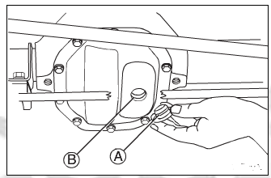
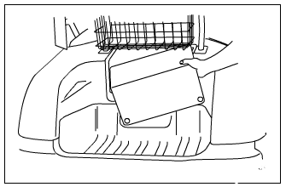

Recommended use:GL5 oil, that is, vehicle heavy duty gear oil.
Gear box capacity:0.65 L
CAUTION
Do not allow other materials to enter the rear axle gearbox.

WARNING
Please make sure to turn off the main switch or the full car without power before the tyres or brakes are repaired.

CAUTION
- When repairing vehicles, please do not wear loose clothing or jewelry, such as rings, watches, etc.
- Please do not try to use the drive motor, which may cause the motor to burn down.
- Please remove all the goods from the vehicle.

Replace the tires
- Please lift the vehicle with the jack or other lifting equipment.
- Note: the lifting height is required to remove the wheel so as not to cause
- unnecessary damage.
- Loosen the wheel retaining nut with the professional tool and remove the tire;
- Please use the opposite step (wheel nut tightening torque 80Nm) when installing.

WARNING
- Only professional technical personnel can carry out the maintenance and maintenance of the system.
- If you doubt that the brake has a problem, please contact the agent before use.The brake failure will lead to serious accidents.

COMMON FAULT TABLE
Mechanical Fault
fault performance | fault causejiejue ban | solution
Tire wear uneven | - Low air pressure  - Toe is incorrect  - Suspension damage | - Inflated to the recommended pressure value  - Adjust the toe value 10-15mm  - Replace damaged parts
Steering is not flexible | - Steering gap is too large  - Steering lever nuts loose  - Bearing damage | - Adjust steering gear clearance,about 1mm.  - Tighten the nut  - Replace bearing
Braking is not sensitive | - Brake shoe wear serious  - With oil or water in the brake  - Brake shoes and the brake drum poor contact  - The brake line is not tightened | - Replace brake shoe  - Clean up oil or water  - Adjust gaps or replace parts  - Adjust the brake cable adjusting lever
Can't park | - Ratchet or ratchet wears badly  - Ratchet or pawl cannot touch | - Replace ratchet or pawl  - Adjust parking adjustment lever
Abnormal sound | - Stall noise caused by motor stall  - Windshield rubs against rubber gasket  - Rear roof abnormal sound,Screw loose | - Replace damaged parts or motors  - Replace rubber gasket  - Tighten loose bolts

LED diagnostics
A built-in Status LED is visible through a window in the label on top of the controller. When the controller detects a fault, the Status LED ﬂashes the 2-digit fault code. The code is ﬂashed continuously until the fault is corrected. For example, code “3,2”—welded main contactor—appears as:
¤ ¤ ¤ ¤ ¤ | ¤ ¤ ¤ ¤ ¤ | ¤ ¤ ¤ ¤ ¤ | etc.
( 3 , 2 ) | ( 3 , 2 ) | ( 3 , 2 )

The codes are listed in the Troubleshooting Chart. Only one fault is indicated at a time, and faults are not queued up. If multiple faults are active simultane- ously, the code of the highest priority fault is ﬂashed. After all faults have been cleared, the code of the last active fault will continue to ﬂash for one minute. This feature is designed to help service personnel identify intermittent faults when no programmer is available.

1266A controller fault table
LED CODE | PROGRAMMER LCD DISPLAY | EXPLANATION | POSSIBLE CAUSE
1.1 | HW FAILSAFE | Self-test or watchdog fault. | Controller defective.
1.2 | THROTTLE FAULT 1 | Wiper signal out of range (pot low fault). | - Throttle input wire open.  - Throttle input wire shorted to B+ or B-.  - Throttle pot defective.
1.3 | SPEED SENSOR FAULT | No pulses from sensor. | - Speed sensor not connected.  - Speed sensor defective.
1.4 | HPD | High Pedal Disable fault. | Improper sequence of direction and throttle inputs.
1.5 | MOTOR STALL | Motor stall at current. | - Slope too steep for vehicle weight.  - Mechanically locked motor.  - EM brake wiring failure.  - Speed sensor defective.
2.1 | LOW BATTERY VOLTAGE | Low battery voltage. | - Battery voltage < undervoltage cutback threshold.  - Corroded battery terminal.  - Loose battery or controller terminal.
2.2 | OVERVOLTAGE | Overvoltage. | - Battery voltage > overvoltage shutdown threshold.  - Vehicle operating with charger attached.  - Battery disconnected during regen braking.
2.3 | THERMAL CUTBACK | Over-/undertemperature cutback. | - Temperature > 85°C or < -25°C.  - Excessive load on vehicle.  - Improper mounting of controller  - Operation in extreme environments.
2.4 | MAIN DRIVER ON | Main contactor coil held low. | - Main contactor missing or wire to coil open.  - Controller defective.
2.5 | AUX COIL FAULT | Missing aux (brake, relay) coil. | - Aux coil open or not connected.  - Breaker/fuse tripped or open.  - Breaker/fuse defective.
3.1 | MAIN DRIVER OFF | Main contactor driver held high. | - Main contactor coil shorted.  - Controller defective.
3.2 | MAIN WELDED | Main contactor welded. | - Main contactor stuck closed.  - Main contactor driver shorted.
3.3 | PRECHARGE FAULT | Internal voltage too low at startup. | - External precharge resistor missing.  - External short, or leakage path to B- on external B+ connection.  - Controller defective.
3.4 | FIELD MISSING | Field winding fault. | - Motor ﬁeld wiring loose.  - Motor ﬁeld wiring open.
3.5 | AUX DRIVER OFF | Aux (brake, relay) driver held high. | - Aux coil shorted.  - Controller defective.
4.1 | CURRENT SENSE FAULT | Armature or ﬁeld current sensor fault. | Controller defective.
4.2 | DRIVER OVERCURRENT | Contactor driver or aux driver overcurrent. | Contactor or aux coil shorted.
4.3 | M- SHORTED | Internal M- short to B-. | Controller defective.
4.4 | AUX RELAY DNC | Aux relay did not close. | Aux relay missing or wire to coil open.
4.5 | WELDED AUX RELAY | Welded aux relay. | - Aux relay stuck closed.  - Aux relay shorted.
5.1 | KEY SWITCH SRO | SRO fault. | - Keywswitch not off at power-up.  - Keyswitch shorted.
5.2 | MAIN COIL OPEN | Missing main contactor. | Main contactor coil open or not connected.
5.3 | AUX DRIVER ON | Aux (EM brake or WalkAway™ relay) driver coil held low. | - Aux output short to ground.  - Controller defective.
5.4 | MAIN DROPOUT | Main contactor open. | Main contactor defective.

TECHNICAL PARAMETERS

Motor and Controller
project | parameter
motor model | KDS（ADC），XP-2067
Motor Type | Dc separately excited motor
rated power | 3.7kw
Rated speed | 2500r/min
Rated torque | 35N·M
Power factor | 0.85
The highest idle speed | 3500r/min
Controller model | Curtis 1266A
Controller type | Dc separately excited motor
Controller capacity | 13.2kV.A
Protection class | IP65

Vehicle parameters
project | parameter
long(mm) | 2510
width(mm) | 11220
height(mm) | 1850
Wheelbase(mm) | 1650
Front track(mm) | 870
Rear track(mm) | 985
Maximum speed(km/h) | forward：22；Recede：9
Maximum grade（%） | 40
Minimum ground clearance(mm) | 114
Minimum turning radius(m) | 2.8

Quality parameters
project | parameter
Curb weight(kg) | 430
Full load quality(kg) | 630

Battery parameters
project | parameter
type of battery | Lead-acid liquid battery
Single voltage(V) | 8
Singlecapacity(Ah) | 145Ah @5-hr rate
Battery total voltage(V) | 48
Total battery capacity(Ah) | 145
Total battery weight(kg) | 174（29*6）
Input voltage(V) | AC 220 50Hz
Input Current(A) | 10
output voltage(V) | 48
Output currentA) | 25

Driving Department
project | parameter
Front suspension type | Mcpherson Independent Suspension
Rear suspension type | Leaf-spring non-independent suspension
Tire specifications | 18×8.5—8
Tire pressure(psi) | 22
Rim specifications | 8×7
Drive axle | High-precision gear，Reduction ratio16:1

Others
project | parameter
Steering mechanism type | gear rack
Steering wheel position | left
Service brake type | Brake line, Drum brakes
Parking brake type | Composite brake or Electronic parking
Rated passenger number | 2人(Including the driver)
Mileage(km) | 60

